

**Software Requirement Specifications**

**EXPENSE EASE**

**Submitted By:**

|  |  |
| --- | --- |
| **P.S.V.S.S.MADHURIMA** | **21N31A66D4** |
| **P.NITHIN** | **21N31A66F1** |
| **ROMALA ABILASH** | **22N35A6616** |

**Under the guidance of**

**G. Deepthi**

**Assoc. Professor**

TABLE OF CONTENTS 2

INTRODUCTION 3

1.LITERATURE SURVEY 3-9

* 1. Existing System 3
  2. Drawbacks of Existing System 4
  3. Proposed System 5
  4. System Architecture 5
  5. Use case 6
  6. Class diagram …………………………………………………...7

1.7 Sequence diagram ………………………………………………8

2.OVERALL DESCRIPTION 9

* 1. Feasibility Study 9
     1. Operational Feasibility 9
     2. Economic Feasibility……………………………………...9
     3. Technical Feasibility 9
     4. Legal and Ethical Feasibility 9

3. SYSTEM ANALYSIS 10

* 1. Software Requirement Specifications 10

3.1.1 Hardware and Software Requirements 10

3.1.2 Hardware Requirements 10

* + 1. Software Requirements 10

4. FUNCTIONAL REQUIREMENTS 11

5. NON FUNCTIONAL REQUIREMENTS 12

6. REFERENCES 13

## INTRODUCTION

Expense Ease is a versatile solution for financial tracking and management, featuring comprehensive CRUD operations for income, expenses, and categories. Users can easily manage their financial records, with the ability to generate detailed monthly reports and filter data by categories. The system supports multi-tenancy, allowing users to access only their own data, while administrators can oversee all user’s information. Customizable options ensure clarity and consistency in displaying financial data. Overall, the project provides a user-friendly platform for effective and organized financial tracking and reporting.

## 1.LITERATURE SURVEY

## 1.1 Existing System:

### User Management: Enables multi-tenancy with individual user access to their own data while allowing administrators to oversee and manage all users' information.

### Income Tracking: Users can log their sources of income to keep track of their earnings alongside their expenses.

### Simple Dashboards: Overview dashboards that provide a snapshot of financial health, showing key metrics like total income, total expenses, and remaining budget.

### 1.2 Drawbacks of Existing System:

* **Limited User Isolation:** Many existing systems lack robust multi-tenancy, meaning individual users don’t have fully isolated environments. This can lead to security concerns where users may inadvertently access data belonging to others.
* **Limited Income Categorization:** In some systems, users can log income, but there is limited support for categorizing income into different sources (e.g., salary, freelance, investments). This can restrict detailed reporting and analysis of earnings.
* **Information Overload:** Dashboards in many systems can become overly complex, cluttered with excessive graphs, charts, and data points, leading to information overload for users. This makes it difficult for users to quickly assess their financial health at a glance.
* **Expense-Centric Design:** Many systems focus heavily on expense tracking but fail to provide comprehensive income tracking. This can make it difficult for users to get a clear picture of their overall financial health, as they can only track what they spend but not what they earn.
* **Weak Data Security:** Some systems do not provide robust encryption or multi-factor authentication (MFA), making them vulnerable to data breaches or unauthorized access.

### 1.3 Proposed System:

### Categorization: Expenses and income can be categorized (e.g., food, transport, salary) to help users see where their money is going.

### Image Upload: Users can upload their profile pictures, making the application feel more personal and allowing users to visually identify their profiles.

### Budget Planning: Allow users to set monthly or yearly budgets for different categories, helping them track spending against their financial goals and receive alerts when approaching or exceeding budget limits.

### Accidental Expenses: This feature allows users to log and track unplanned or unforeseen costs separately from their regular, planned budget.

### Income and Expense Reports: Generate detailed, customizable reports that provide insights into spending trends, income sources, and budget performance.

### 1.4 System Architecture:

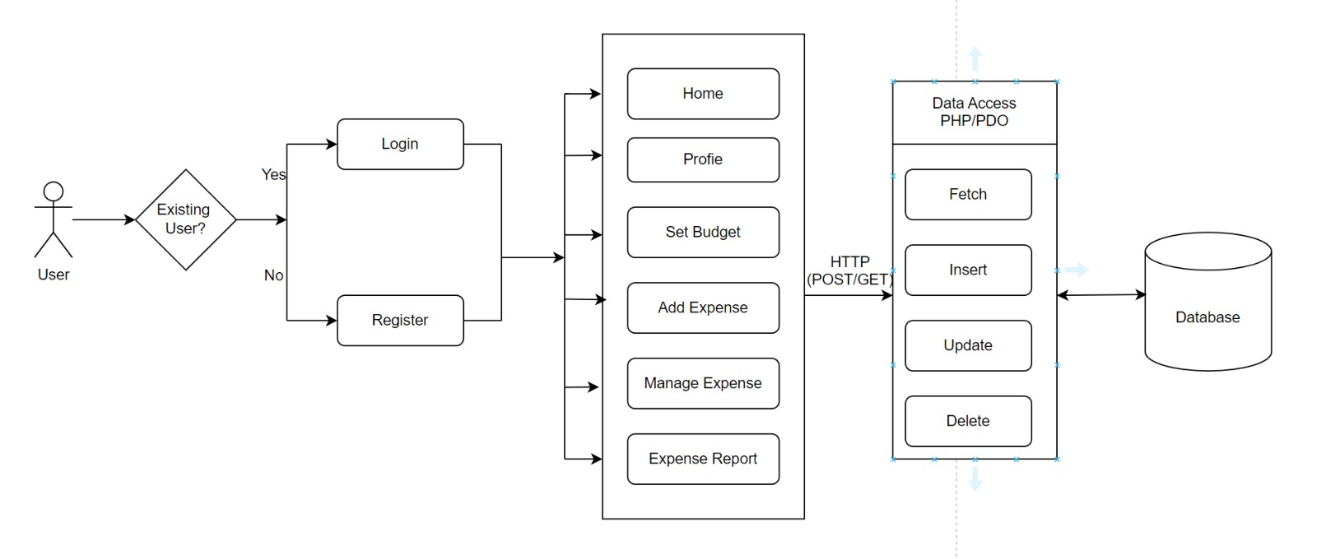

* 1. **Use-case Diagram:**

A UML use case diagram is the primary form of system/software requirements for a new software program underdeveloped. Use cases specify the expected behavior (what), and not the exact method of making it happen (how). Use cases once specified can be denoted both textual and visual representation (i.e. use case diagram). A key concept of use case modeling is that it helps us design a system from the end user's perspective. It is an effective technique for communicating system behavior in the user's terms by specifying all externally visible system behavior.

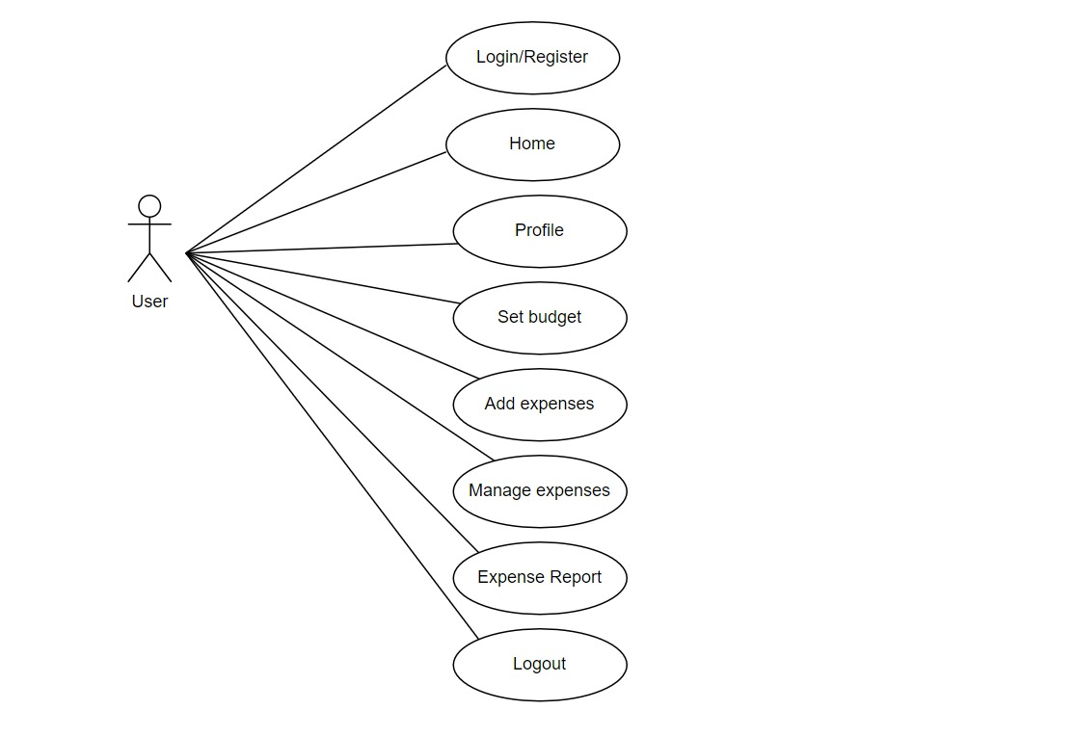

* 1. **Class Diagram:**

Class diagrams are a type of UML (Unified Modeling Language) diagram used in software engineering to visually represent the structure and relationships of classes in a system. UML is a standardized modeling language that helps in designing and documenting software systems. They are an integral part of the software development process, helping in both the design and documentation phases.

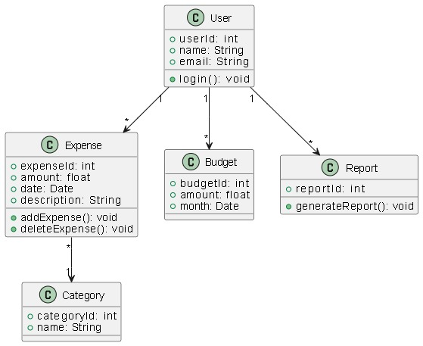

* 1. **Sequence Diagram:**

A sequence diagram shows process interactions arranged in time sequence. This diagram depicts the processes and objects involved and the sequence of messages exchanged as needed to carry out the functionality. Sequence diagrams are typically associated with use case realizations in the 4+1 architectural view model of the system under development. Sequence diagrams are sometimes called event diagrams or event scenarios.

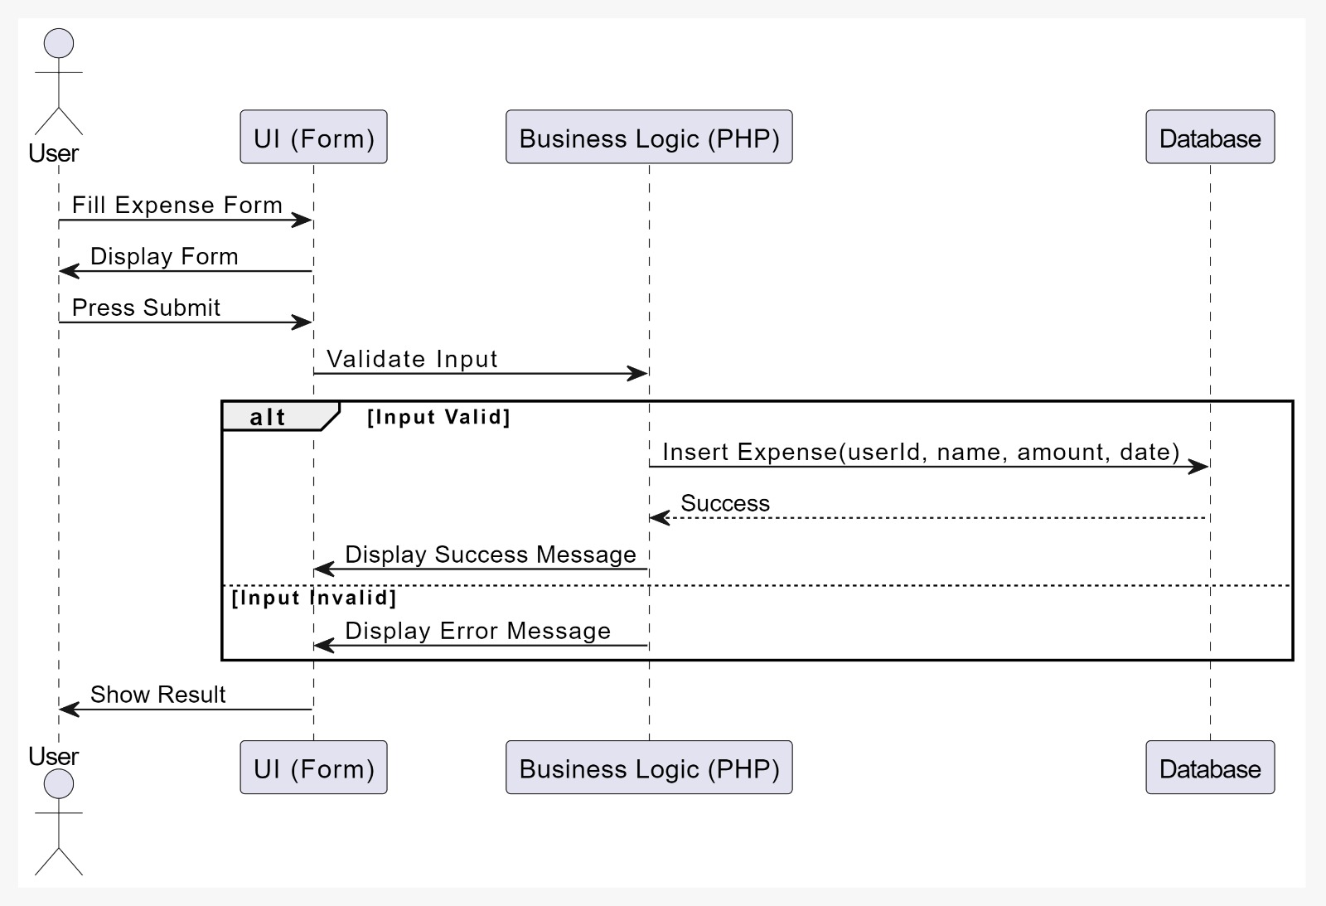

# 

# 2.OVERALL DESCRIPTION

### 2.1 Feasibility Study:

#### 

#### 2.1.1 Operational Feasibility:

#### The operational feasibility of this project is high, as the system is designed to streamline personal and small business financial management by offering user-friendly features like multi-tenancy, income and expense tracking, and intuitive dashboards. The simplicity of the interface ensures that both tech-savvy and non-technical users can navigate and utilize the system with minimal training. Furthermore, the user-friendly design enhances accessibility, allowing users to track their finances on-the-go. With robust user management and administrative controls, the system ensures secure handling of multiple user accounts, making it feasible for daily operations in both individual and administrative contexts.

#### 2.1.2 Economical Feasibility:

#### The economic feasibility of Expense Ease is promising due to its cost-effective development and potential for high user adoption. By utilizing open-source technologies such as PHP, MySQL, HTML, and CSS for the web platform, development costs are minimized while maintaining robust functionality. The platform’s features, such as multi-tenancy, income tracking, and attractive dashboards, offer high value to users. Furthermore, its low operational costs, combined with the potential to scale for both individual users and small businesses, ensures a favorable return on investment. This makes this project economically viable in the long term.

#### 2.1.3 Technical Feasibility:

#### This project is technically feasible, using reliable technologies like PHP, MySQL, and HTML/CSS, which are well-supported and easy to scale. Key features like multi-tenancy and expense reporting are achievable with existing frameworks, and a mobile-responsive design ensures smooth cross-device use. The system’s architecture supports future upgrades, making it sustainable for long-term deployment.

#### 2.1.4 Legal and Ethical Feasibility:

#### This project is legally and ethically feasible by adhering to data protection laws like GDPR, ensuring secure data handling, and providing transparency in privacy policies. Ethical practices, such as giving users control over their data and preventing misuse, further support its compliance and trustworthiness.

# 3.SYSTEM ANALYSIS

### Software Requirement Specifications:

A software requirements specification (SRS) is a comprehensive description of the intended purpose and environment for software under development. The SRS fully describes what the software will do and how it will be expected to perform. An SRS minimizes the time and effort required by developers to achieve desired goals and minimizes the development cost. A good SRS defines how an application will interact with system hardware, other programs, and human users in a wide variety of real-world situations. Hence, we start the srs with the feasibility study.

### Hardware and Software Requirements:

### Software and Hardware Requirements. All computer software needs certain hardware components or other software resources to be present on a computer. These prerequisites are known as (computer) system requirements and are often used as a guideline as opposed to an absolute rule.

#### 3.1.2 Hardware Requirements

#### Processor : Intel Core i3 or better

#### RAM : 8 GB DDR3

#### Hard Disk Drive : 30GB

#### Software Requirements

* **Operating System:** Windows 7/8/8.1/10/11 (64-bit)
* **Coding language:** PHP
* XAMPP Server
* MySQL
* Visual Studio Code

# 

# 4.FUNCTIONAL REQUIREMENTS

**1.User Authentication and Authorization:**

The system shall allow users to register, log in, and manage their profiles, with each user having access to their own financial data in a multi-tenant environment.

**2.** **Expense Tracking:**

The system shall enable users to add, edit, and delete expense records, categorizing expenses by different types (e.g., food, transportation, entertainment).

**3. Income Tracking:**

The system shall allow users to log their income from various sources, categorizing income entries for better financial analysis.

**4.** **Budget Management:**

The system shall allow users to set, update, and manage their budget limits, tracking their spending against their defined categories and overall budget.

**5. Dashboard Overview:**

The system shall display a simple, interactive dashboard providing an overview of total income, total expenses, remaining budget, and category-wise breakdown.

**6. Report Generation:**

The system shall generate detailed reports for expenses and income, categorized by date (daily, monthly, yearly) and by type, helping users track financial patterns.

**7.** **Expense Categorization:**

The system shall allow users to create, manage, and assign custom categories to both income and expenses for detailed tracking and reporting.

## 5.NON FUNCTIONAL REQUIREMENTS

#### 5.1 Accuracy and Reliability:

#### The system ensures precise tracking by allowing users to log and categorize each expense and income entry, minimizing the chances of data entry errors.

#### The system incorporates validation checks during data entry for expenses and income, ensuring users input accurate information and reducing the likelihood of errors.

#### The system generates detailed, reliable reports for expenses and income, categorized by date and type, providing users with accurate insights into their financial patterns.

#### 5.2 Scalability and Performance:

#### The system is designed with a modular architecture that allows for easy addition of new features and functionalities, enabling it to scale effectively as user needs evolve and demand increases.

#### The application employs optimized database queries and indexing to ensure fast retrieval and processing of user data, maintaining high performance even with a growing number of users and extensive financial records.

#### 5.3 Security and Privacy:

#### The system requires users to create strong, unique passwords and implements measures such as hashing and salting to securely store passwords, protecting accounts from unauthorized access.

#### The platform provides clear privacy policies and obtains user consent for data collection and processing, allowing users to manage their privacy settings and control what information is shared or stored.

#### 5.4 Usability and User Experience:

#### The system features a user-friendly and intuitive interface that simplifies navigation, allowing users to easily access and manage their financial information without requiring extensive training.

#### The application employs a responsive design that ensures a seamless experience across various devices, enabling users to track their expenses and income conveniently from desktops, tablets, or smartphones.

## 6. REFERENCES:

1. Dr. C K Gomathy, Article: A Study on the recent Advancements in Online Surveying, International Journal of Emerging technologies and Innovative Research ( JETIR ) Volume 5 | Issue 11 | ISSN : 2349-5162, P.No:327-331, Nov-2018

2. “Why We Need to Start Budget Tracking Now” by David Ning.

1. A Research Paper on Blood Donation
2. Management System 1Devanjan K.
3. Srivastava, 2Utkarsh Tanwar,
4. 3M.G.Krishna Rao, 4Priya Manohar,
5. 5Balraj Singh 1234Student, Computer
6. Science Engineering, 5Assistant Professor,
7. School of Computer Science Engineering
8. 12345Lovely Professional University,
9. Jalandhar, India

3. https://www.w3schools.com

4. <https://youtu.be/r0lDDeVkaks?si=T-A8vQ51SD0ijSfK>

5. <https://youtu.be/N676lCQq4n8?si=AygcszsveLOzpfmK>